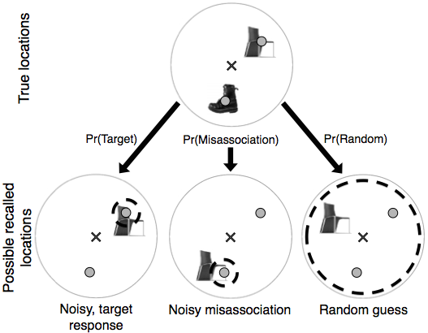
Figure 3. Schematic of the types of errors we aim to characterize with the mixture model: imprecise report of the target, misassociation, or random guess (illustrated with just two objects that are displayed disproportionately large for visual clarity). The top-row shows the true locations of the objects and the bottom-row shows possible types of responses. Grey dots represent the locations of the target object (the chair) and a possible non-target object (the boot). The grey X indicates the center of the environment. We use the mixture model to estimate the probability of each type of error, denoted here by Pr(Target), Pr(Misassociation) and Pr(Random). If there are multiple non-target objects, Pr(Misassociation) is divided evenly among them. Under our error model, target reports and misassociations are recalled with isotropic, two-dimensional Gaussian noise around the selected location (small, grey dashed circles). The model treats random guess responses as samples from a broad, truncated, two-dimensional Gaussian distribution around the display center (large, dashed circle).

